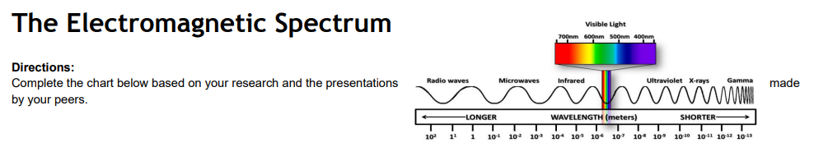
Wave | Location | Description | Uses
Radio wave
Microwave
Infrared wave
Visible light
Ultraviolet ray
X-ray
Gamma ray

